EVALUATION OF FAIRY TALES LIFE WORKSHOP - PARTICIPANTS
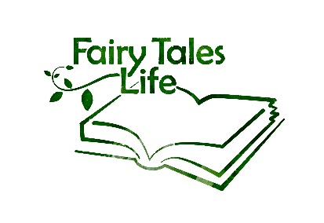

Name participant:

PARTICIPATION

1. How much did you feel included and engaged with the group during the whole workshop?
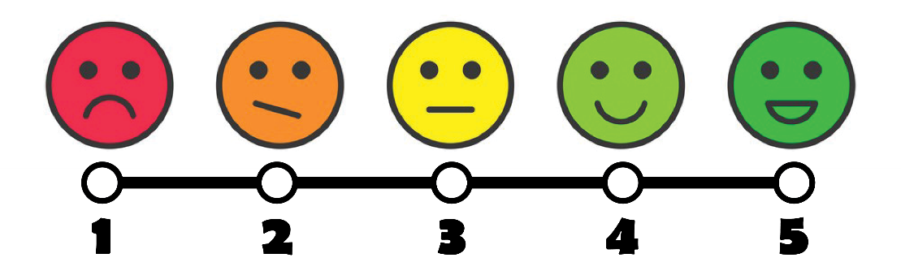

2. How much did the group engage / include you during the whole workshop?

3. How has your participation in groups changed through this workshop? Can you describe it?

AWARENESS

4. Did you become more curious towards the other youngsters personal stories and perspectives through the workshop?

5. Do you feel like the other youngsters became more curious towards your personals story and perspectives through the workshop?

6. How has this workshop helped you to become more aware of others perspectives?

DIALOGUE

7. Do you feel more comfortable expressing your personal opinion through the workshop?

8. Did you become more open-minded towards others opinions and perspectives since the workshop?

9. What was a perspective of someone else that really surprised you? Can you describe it?

GENERAL

What part of the workshop did you like the most? And why?

How can you use what you learned in the workshop in your daily life?

Anything else?

