EVALUATION OF FAIRY TALES LIFE WORKSHOP - TEACHERS
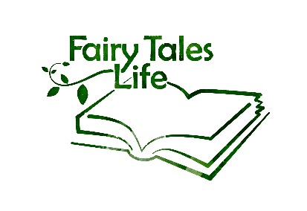

Thank you for helping us evaluate the storytelling cards workshop(s) within the “Fairy Tales Life” project. As a teacher or mentor you see the students on a regular basis, which gives you the opportunity to see changes or developments of the students that we as workshop facilitators cannot see. For this reason we would like to ask you to fill in the evaluation form as detailed as possible. Your feedback is very valuable to us and the whole project.

Please describe both changes within the group/class of students and changes on an individual level. You do not have to mention the names of individual students, but if you noticed that something changed in an individual student then please write down which change you have seen.

Name of Teacher:
Date of evaluation:

PARTICIPATION

1. What changes or developments in the participation of the students during school activities (lessons, activities, tasks, breaks etc.) have you seen since the workshop(s)?

AWARENESS

2. What changes or developments in the awareness of students towards each other have you seen since the workshop(s)? Are they more curious towards the other youngsters personal stories and perspectives? Did you see any change in empathy towards each other with the students?

DIALOGUE

3. What changes or developments do you see in the dialogue between the students? Do you see any change in the students expressing their personal opinions? Do you see any change in the students in exchanging their opinions and perspectives?

CRITICAL THINKING

4. What changes or developments in the critical thinking of students have you seen since the workshop(s)? Are they questioning each other more? Are they more critical towards their own and others opinions?

PERSPECTIVES

5. What changes or developments have you seen since the workshop(s) in the way that the students recognize their own and others perspectives? Is there a change in the way are they able to see things from a different or new perspectives?

MUTUAL RECOGNITION

6. What changes or developments have you seen in the way that the students recognize similarities and differences between them, since the workshop(s)? Is there any mutual recognition between the students? Do you see empathy towards others stories and perspectives? Are the students better at connecting other stories and perspectives to their own?

GENERAL

7. Do you see any other changes or developments in the students since the workshop?

7. Is there anything which surprised you or that you did not expect to happen, which you can link to students doing the workshop(s)?

8. Anything else or comments you would like to give us / share with us?

We want to thank you very much for taking the time and effort of filling in the evaluation form for us! Your observations are very valuable for us and will be useful for the further development of our project.

